EMBARGOED UNTIL 14 July 2015

Australia captures world first close-ups of Pluto!
After nine-and-a-half years and just over 5 billion km, the much anticipated and incredibly long awaited close-up view of Pluto is finally over.  NASA’s spacecraft New Horizons will make its closest encounter with Pluto at exactly 9:49.57pm (AEST) tomorrow [14 July 2015].  CSIRO’s Canberra Deep Space Communication Complex (CDSCC) will be the first place on Earth to receive the closest encounter images as it’s sent through from the space probe.  The world will see for the first time what Pluto actually looks like as the spacecraft flies 12,500 km above the surface, taking detailed measurements and images of the dwarf planet and its moons.  CDSCC is part of NASA’s Deep Space Network and is one of only three tracking stations in the world that has the technology and people with the capabilities to provide the vital two-way radio contact with spacecraft like New Horizons at such incredible distances from Earth.  “We have tracked New Horizons since its launch in January 2006 and are currently receiving the latest images and telemetry from the spacecraft which allows the mission team to make decisions about course corrections and to begin the key science observations,” Director of the CDSCC Dr Ed Kruzins said.  Radio signals from New Horizons will take about 4.5 hours to reach the CDSCC. By the time the signal reaches Earth they will be incredibly weak, practically tiny whispers. However thanks to the big dish’s high sensitivity on Earth at CDSCC , Pluto will come in loud and clear.  There will be so much data collected it will take up to a year before all of the images and science observations made by the spacecraft are fully transmitted back to Earth.  Head of CSIRO’s Astronomy and Space Science, Dr Lewis Balls said the New Horizons mission was one of the great explorations of our time.  “There is so much we don’t know and not just about Pluto, but also about similar worlds,” Dr Ball said.  “Reaching this part of our solar system has been a space science priority for years, because it holds building blocks of our solar system that have been stored in a deep freeze for billions of years.”  While Pluto was downgraded from a planet to a dwarf planet in 2006, it is thought to contain important clues about the origins of the Solar System. These icy bodies are thought to be relics of the materials that originally built up to become the larger planets. This will be the first time that scientists can study this process as it happens.  “CDSCC has been involved in many of space exploration’s greatest moments, from capturing images of the first moon walk to receiving amazing views from the surface of Mars, and the first ‘close-ups’ of Jupiter, Saturn, Uranus and Neptune,” Dr Ball said.;  “Capturing Pluto will be the capstone of this amazing space adventure.  “CSIRO is capturing space history in the making. We will be rewriting textbooks and science that will be taught in the classrooms of tomorrow.” | Contact  Indra Tomic  +61 8 6436 8809  +61 (0)404 023 806  indra.tomic@csiro.au  Glen Nagle  +61 2 6201 7838  +61 (0)477 379 959  glen.nagle@csiro.au      CSIRO is on Facebook, Twitter, YouTube and LinkedIn.  Visit the News@CSIRO blog.
ADDITIONAL RESOURCES
Available on Cloudstor drop box
https://cloudstor.aarnet.edu.au/plus/public.php?service=files&t=b3dfd2dd7d8fdf476cc0d39c4ca052c8

Images

 | Image file name: nh-pluto-approaches-charon.jpg  Caption: Artist’s concept of the New Horizons spacecraft as it approaches Pluto and its largest moon, Charon  Credit: NASA/JHUAPL/SWRI
 | Image file name: CDSCC-from-Larrys-Hill.jpg  Caption: Canberra Deep Space Communication Complex capturing whispers from space from the hills of Tidnbibilla, ACT.  Credit: CSIRO CDSCC
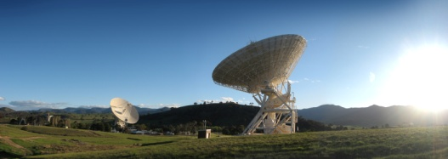 | Image file name: voyager1_2-tracking.jpg  Caption: Canberra Deep Space Communication Complex tracking the New Horizons spacecraft every step of its space voyage.  Credit: CSIRO CDSCC
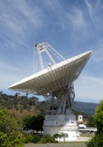 | Image file name: DSS43_A3e.jpg  Caption: Deep Space Station 43 is the largest antenna in the southern hemisphere.  Credit: CSIRO CDSCC

Fact sheet
B-roll
Radio grabs
Simulations

