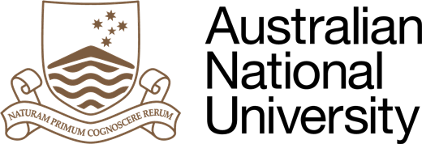 | 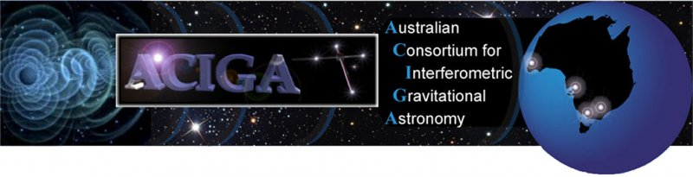
THURSDAY 11 FEBRUARY 2016

GRAVITATIONAL WAVE SEARCH RESULTS ANNOUNCED

Australian researchers on Friday will hold a media conference to announce results of the most recent search for gravitational waves.

Media are invited to join the Chief Scientist Dr Alan Finkel, the CEO of the Australian Research Council, Professor Aidan Byrne and ANU Vice-Chancellor and Nobel Laureate, Professor Brian Schmidt, AC.

Australian researchers from six universities and CSIRO have made key contributions to LIGO.

The Australian announcement will be at 10am Friday 12 February at Parliament House, Canberra.

Gravitational waves are tiny ripples in space and time caused by large scale events such as collisions or explosions of stars. They were predicted 100 years ago by Einstein’s Theory of Relativity, but many scientists thought they are too small to be detected.

Australian gravitational waves research is coordinated by Australian Consortium for Interferometric Gravitational Astronomy www.aciga.org.au .

International announcement: http://www.ligo.org/news/media-advisory.php.
___________________________________________________________________

WHAT: Australian announcement of gravitational wave search results
WHO:
- Chief Scientist Dr Alan Finkel
- CEO Australian Research Council, Professor Aidan Byrne
- ANU Vice-Chancellor and Nobel Laureate Professor Brian Schmidt AC
- Senator Zed Seselja (representing the Minister for Education)
- Scientists from the Australian National University (ANU), University of Western Australia, The University of Adelaide, the University of Melbourne, Monash University and Charles Sturt University

WHERE: Senate Alcove, Parliament House

WHEN: 10am Friday 12 February 2015

For media assistance, contact the ANU media hotline on (02) 6125 7979.

ACIGA partners
 | 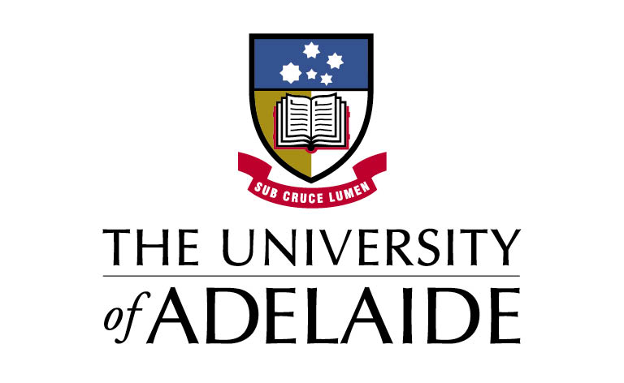 | 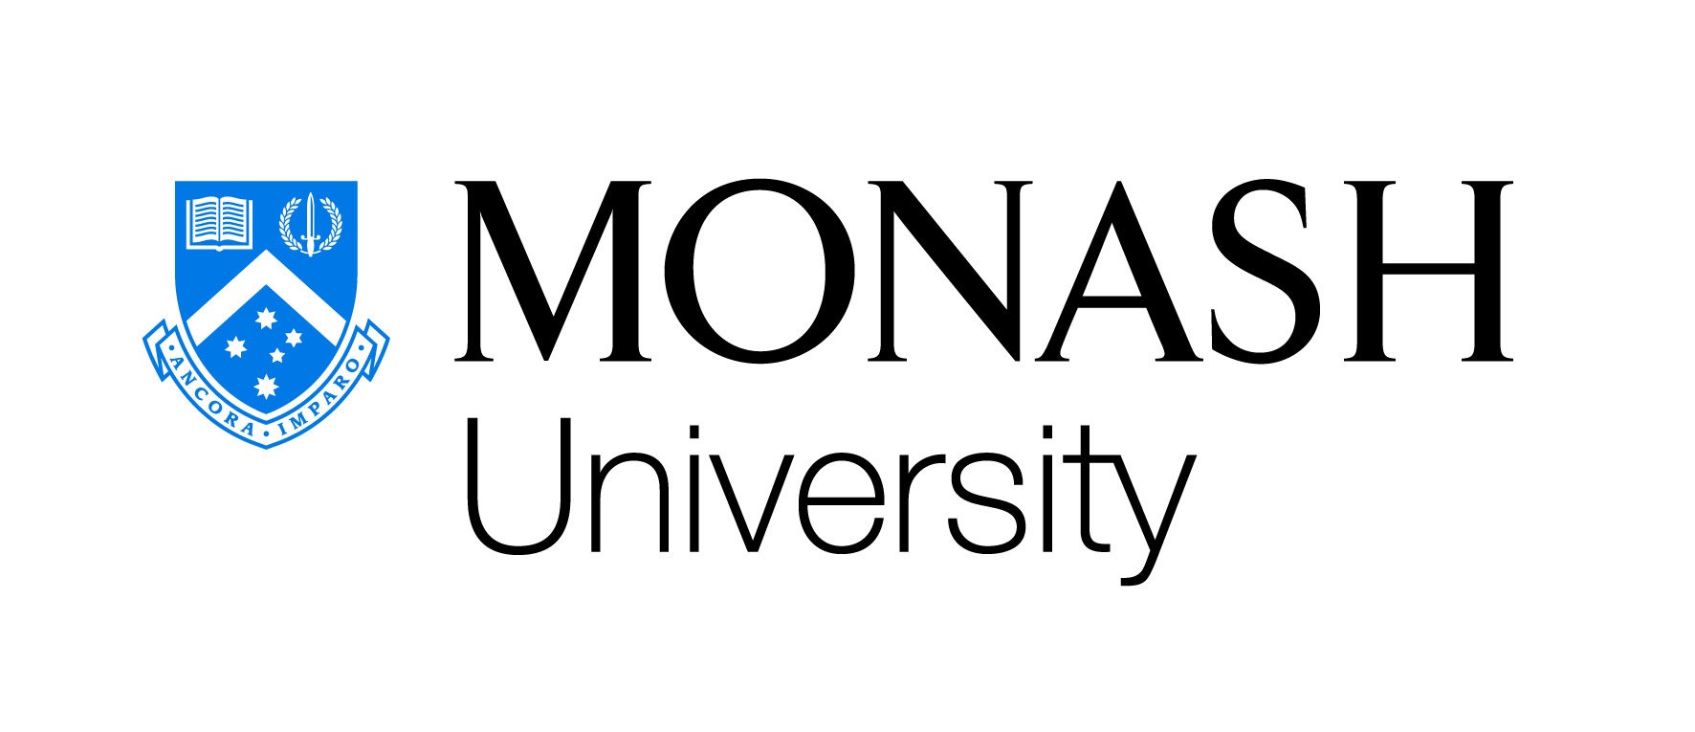
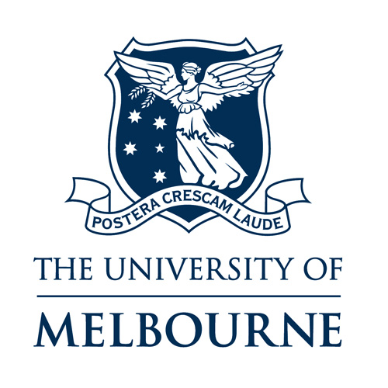 | 