**AI risks overwriting history and the skills of historians have never been more important, leading academic outlines in new paper**

**AI “essentially ignores” the extent of what Holocaust survivors endured on an emotional level – when put to the test by a Cornell historian**

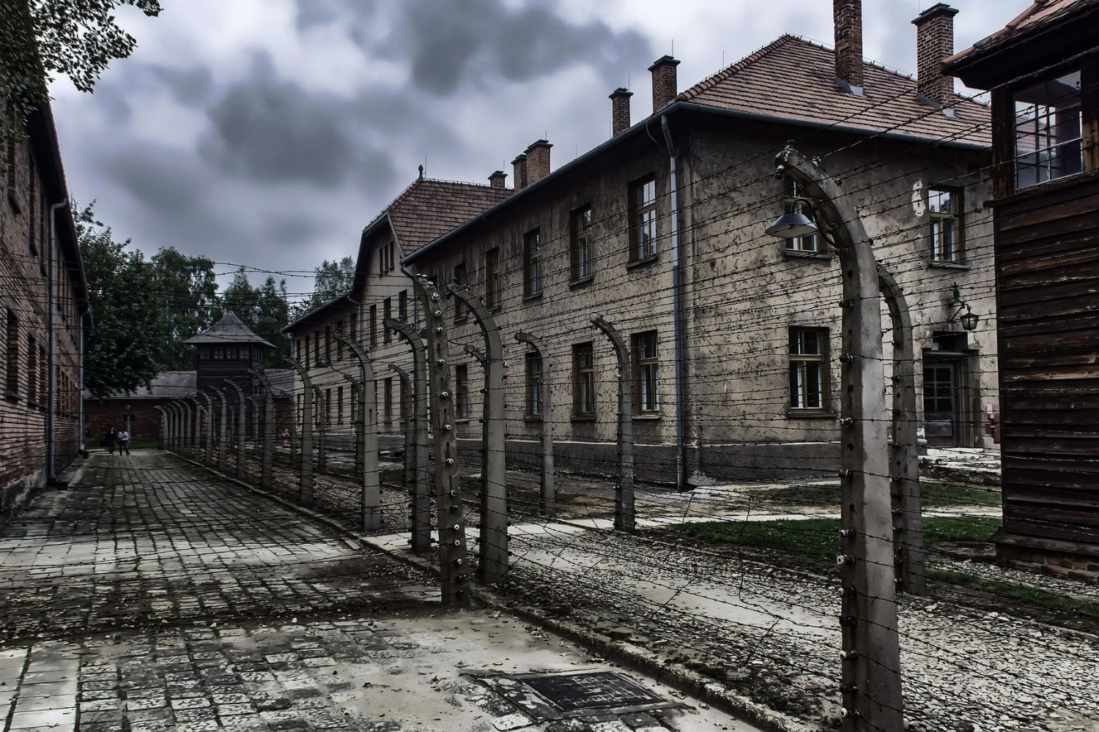  
*Image by peter89ba on Pixabay*

**\*\*UNDER EMBARGO until Monday 15th September at 00:01 Eastern Time\*\***

**For a copy of the paper under embargo, please click 'Download PDF' below.**

Human historians are ever more vital in the age of AI – especially with the crucial need to capture the emotional and moral complexity behind world events.

That’s according to a leading academic Dr Jan Burzlaff, an expert on Nazi Germany from Cornell University, who when tasking ChatGPT to summarize the experiences of Holocaust survivors found the AI tool failed to capture intimate, vital details.

“With the testimony of Luisa D., a seven-year-old Holocaust survivor, AI overlooked heartbreaking details about her mother cutting her own finger to give her dying child drops of blood – ‘the faintest trace of moisture’ – to stay alive.

“This omission alone demonstrates why human historians remain indispensable in the age of artificial intelligence.

“Historical writers possess skills that AI currently lacks – especially the ability to capture human suffering,” Dr Burzlaff, a postdoctoral associate in the Jewish Studies Program in the College of Arts and Sciences, states.

“If historical writing can be done by a machine, then it was never historical enough.”

His findings are published today in the peer-reviewed journal [*Rethinking History*](https://tandfonline.com/doi/full/10.1080/13642529.2025.2546174?username=lyndal_byford), in a piece which analyses Chat GPT’s attempts to recapitulate recorded testimonies of Holocaust survivors made in La Paz, Kraków and Connecticut in 1995.

The results expose the limits of AI, which creates new content based on what it learns from existing data. It outlines that whilst AI can identify angles that historians may not have considered, the downside is algorithms may distort history or, as in this instance, try to clarify the Holocaust which he says, “cannot be resolved”.

“Essentially it ignored the extent these individuals suffered on an emotional level,” Dr Burzlaff states.

“A recent study by Microsoft ranked historians as high on the list of jobs that AI could replace. But AI lacks the ability to capture human suffering.

“If it falters with Holocaust testimony — the most extreme case of human suffering in modern history — it will distort more subtle histories too. Holocaust testimony is a litmus test for AI, where smoothing and summarisation run up against the obligation to preserve fracture, silence and ethical weight.”

He adds: “As tools like ChatGPT increasingly saturate education, research, and public discourse, historians must reckon with what these systems can and cannot do.

“They summarize but do not listen, reproduce but do not interpret, and excel at coherence but falter at contradiction.

“The problem we historians now face is not whether AI can recognize meaning, but whether we will continue to do so.”

The article shares five guidelines developed for teachers, academics and anyone else writing about history in the modern era – especially for those teaching about trauma, genocide and historical injustice.

The author says his advice will help historians hold on to the ‘ethical, intellectual, and stylistic stakes of historical writing’.

“AI feeds on pattern, frequency, and proximity. Historians should avoid this approach – they should draw from written testimonies, not become a collection of texts,” Dr Burzlaff outlines.

“Essentially, as historians we should not try to ‘outperform the machine’ but to sound nothing like it.

“At stake is not only the memory of the Holocaust, as in this instance, but how societies everywhere will remember and interpret their pasts in the age of prediction.

“The accounts of people from the past differ according to their individual experiences and some are different to categorize. Historians need to embrace this lack of uniformity and moments of human experience that algorithms cannot anticipate.”

**FURTHER INFORMATION**

**For an interview, please contact:**  
Jan Burzlaff  
Email: [jb2825@cornell.edu](mailto:jb2825@cornell.edu?username=lyndal_byford)

Simon Wesson, Media Relations Manager  
Email: [newsroom@taylorandfrancis.com](mailto:newsroom@taylorandfrancis.com?username=lyndal_byford)  
Follow us on Twitter: [@tandfnewsroom](http://twitter.com/tandfnewsroom?username=lyndal_byford)  
Follow up on Bluesky: [@tandfresearch](https://bsky.app/profile/tandfresearch.bsky.social?username=lyndal_byford) / [@routledgebooks](https://bsky.app/profile/routledgebooks.bsky.social?username=lyndal_byford)

The article will be freely available once the embargo has lifted via the following link: [https://tandfonline.com/doi/full/10.1080/13642529.2025.2546174](https://tandfonline.com/doi/full/10.1080/13642529.2025.2546174?username=lyndal_byford)

About Taylor & Francis Group  
[Taylor & Francis](https://taylorandfrancis.com/?username=lyndal_byford) supports diverse communities of experts, researchers and knowledge makers around the world to accelerate and maximize the impact of their work. We are a leader in our field, publish across all disciplines and have one of the largest Humanities and Social Sciences portfolios. Our expertise, built on an academic publishing heritage of over 200 years, advances trusted knowledge that fosters human progress.  
Our 2,500+ people, based in a global network of offices in more than 15 countries, use their skills and the latest technology to curate, validate and share impactful advanced, emergent and applied knowledge. Under the Taylor & Francis, Routledge and F1000 imprints we publish 2,700 journals, 8,000 new books each year and partner with more than 700 scholarly societies.  
Taylor & Francis is proud to be a Global Certified Accessible™ publisher and our operations and all our print publications are certified CarbonNeutral®.