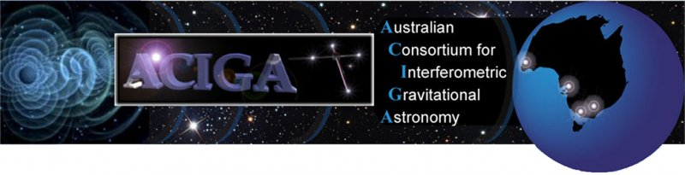
GRAVITATIONAL WAVES DETECTED 100 YEARS AFTER EINSTEIN’S PREDICTION

LIGO Opens New Window on the Universe with Observation of Gravitational Waves from Colliding Black Holes

Australian scientists play a key role in major discovery

For the first time, scientists have observed ripples in the fabric of spacetime called gravitational waves, arriving at the earth from a cataclysmic event in the distant universe. This confirms a major prediction of Albert Einstein’s 1915 general theory of relativity and opens an unprecedented new window onto the cosmos.

Gravitational waves carry information about their dramatic origins and about the nature of gravity that cannot otherwise be obtained. Physicists have concluded that the detected gravitational waves were produced during the final fraction of a second of the merger of two black holes to produce a single, more massive spinning black hole. This collision of two black holes had been predicted but never observed.

The gravitational waves were detected on September 14, 2015 at 5:51 a.m. Eastern Daylight Time (9:51 a.m. UTC) by both of the twin Laser Interferometer Gravitational-wave Observatory (LIGO) detectors, located in Livingston, Louisiana, and Hanford, Washington, USA. The LIGO Observatories are funded by the National Science Foundation (NSF), and were conceived, built, and are operated by Caltech and MIT.

The discovery, accepted for publication in the journal Physical Review Letters, was made by the LIGO Scientific Collaboration (which includes the Australian Consortium for Interferometric Gravitational Astronomy (ACIGA) and the GEO600 Collaboration) and the Virgo Collaboration using data from the two LIGO detectors.

Australian scientists from The Australian National University (ANU), the University of Adelaide, The University of Melbourne, the University of Western Australia (UWA), Monash University and Charles Sturt University, contributed to the discovery and helped build some of the super-sensitive instruments used to detect the gravitational waves.

Leader of the Australian Partnership in Advanced LIGO Professor David McClelland from ANU, said the observation would open up new fields of research to help scientists better understand the universe.

“The collision of the two black holes was the most violent event ever recorded,” Professor McClelland said.

“To detect it, we have built the largest experiment ever – two detectors 4,000 kilometres apart – with the most sensitive equipment ever made, which has detected the smallest signal ever measured.”

Associate Professor Peter Veitch from University of Adelaide said the discovery was the culmination of decades of research and development in Australia and internationally.

“The Advanced LIGO detectors are a technological triumph and the discovery has provided undeniable proof that Einstein’s gravitational waves and black holes exist,” Professor Veitch said.

“I have spent 35 years working towards this detection and the success is very sweet.”

Professor David Blair from UWA said the black hole collision detected by LIGO was invisible to all previous telescopes, despite being the most violent event ever measured.

“Gravitational waves are akin to sound waves that travelled through space at the speed of light,” Professor Blair said.

“Up to now humanity has been deaf to the universe. Suddenly we know how to listen. The universe has spoken and we have understood.”

With its first discovery, LIGO is already changing how astronomers view the universe, said LIGO researcher Dr Eric Thrane from Monash University.

“The discovery of this gravitational wave suggests that merging black holes are heavier and more numerous than many researchers previously believed,” Dr Thrane said.

“This bodes well for detection of large populations of distant black holes – research carried out by our team at Monash University. It will be intriguing to see what other sources of gravitational waves are out there, waiting to be discovered.”

The success of LIGO promised a new epoch of discovery, said Professor Andrew Melatos, from The University of Melbourne.

“Humanity is at the start of something profound. Gravitational waves let us peer right into the heart of some of the most extreme environments in the Universe, like black holes and neutron stars, to do fundamental physics experiments under conditions that can never be copied in a lab on Earth,” Professor Melatos said.

“It is very exciting to think that we now have a new and powerful tool at our disposal to unlock the secrets of all this beautiful physics.”

Dr Philip Charlton from Charles Sturt University said the discovery opened a new window on the universe.

“In the same way that radio astronomy led to the discovery of the cosmic microwave background, the ability to ‘see’ in the gravitational wave spectrum will likely to lead to unexpected discoveries,” he said

Professor Susan Scott, who studies General Relativity at ANU, said observing this black hole merger was an important test for Einstein’s theory.

“It has passed with flying colours its first test in the strong gravity regime which is a major triumph.”

“We now have at our disposal a tool to probe much further back into the Universe than is possible with light, to its earliest epoch."

Australian technology used in the discovery has already spun off into a number of commercial applications. For example, development of the test and measurement system MOKU:Labs by Liquid Instruments; vibration isolation for airborne gravimeters for geophysical exploration; high power lasers for remote mapping of wind-fields, and for airborne searches for methane leaks in gas pipelines.

LIGO research is carried out by the LIGO Scientific Collaboration (LSC), a group of more than 1000 scientists from universities around the United States and in 14 other countries. More than 90 universities and research institutes in the LSC develop detector technology and analyse data; approximately 250 students are strong contributing members of the collaboration.

The LSC detector network includes the LIGO interferometers and the GEO600 detector. The GEO team includes scientists at the Max Planck Institute for Gravitational Physics (Albert Einstein Institute (AEI)), Leibniz Universität Hannover, along with partners at the University of Glasgow, Cardiff University, and other universities in the United Kingdom, funded by Science and Technology Facilities Council (STFC). Significant computer resources have been contributed by the AEI Atlas cluster, the LIGO Laboratory, Syracuse University, and the University of Wisconsin Milwaukee.

LIGO was originally proposed as a means of detecting these gravitational waves in the 1980s by Rainer Weiss, professor of physics, emeritus, from MIT; Kip Thorne, Caltech’s Richard P. Feynman Professor of Theoretical Physics, emeritus; and Ronald Drever, professor of physics, emeritus, also from Caltech.

Virgo research is carried out by the Virgo Scientific Collaboration, a group of more than 250 physicists and engineers belonging to 18 different European laboratories, 6 of Centre National de la Recherche Scientifique (CNRS) in France, 8 of Istituto Nazionale di Fisica Nucleare (INFN) in Italy, Nikhef in the Netherlands, the Wigner Institute in Hungary, the POLGRAW group in Poland and the European Gravitational Observatory (EGO), the laboratory hosting the Virgo interferometer.

The discovery was made possible by the enhanced capabilities of Advanced LIGO, a major upgrade that increases the sensitivity of the instruments compared to the first-generation LIGO detectors, enabling a large increase in the volume of the universe probed—and the discovery of gravitational waves during its first observation run. The U.S. National Science Foundation leads in financial support for Advanced LIGO. Funding organizations in Germany (Max Planck Society), the U.K. (STFC) and Australia (Australian Research Council) also have made significant commitments to the project. Several of the key technologies that made Advanced LIGO so much more sensitive have been developed and tested by the German UK GEO collaboration.

FOR INTERVIEW

THE AUSTRALIAN NATIONAL UNIVERSITY
Professor David McClelland
Research School of Physics and Engineering
T: +61 2 6125 9888
M: 0402 395 120
E: David.McClelland@anu.edu.au
Professor Susan Scott
Research School of Physics and Engineering
T: +61 2 6125 0347
M: 0450 522 939
E: Susan.Scott@anu.edu.au

UNIVERSITY OF ADELAIDE
Associate Professor Peter Veitch,
Head of Physics, University of Adelaide
M: +61 422 906 827
E: peter.veitch@adelaide.edu.au
MONASH UNIVERSITY
Dr Eric Thrane
School of Physics and Astronomy
T: +61 399-020-393
M: +61 450 765 993
E: eric.thrane@monash.edu
UNIVERSITY OF MELBOURNE
Professor Andrew Melatos
School of Physics
T: +61 3 8344 5436 (while in Canberra on Fri 12/2, call ANU media office)
E: amelatos@unimelb.edu.au
UNIVERSITY OF WESTERN AUSTRALIA
David Blair, Winthrop Professor
Director, Australian International Gravitational Research Centre
T: +61 8 6488 2736
M: +61 409 687 703
E: david.blair@uwa.edu.au
Associate Professor Li Ju
School of Physics
T: +61 8 6488 1033
M: +61 402 389 240
E: li.ju@uwa.edu.au

CHARLES STURT UNIVERSITY
Dr Philip Charlton
School of Computing and Mathematics
T: +61 2 6933 4104
E: pcharlton@csu.edu.au
CSIRO
Dr Cathy Foley
Science Director, Manufacturing
M: +61 419 200 544
E: Cathy.Foley@csiro.au

AUSTRALIAN RESEARCH CONTRIBUTIONS
ANU designed, constructed, installed and commissioned a system that stabilises the system and locks the laser and mirrors to each other at the start of experiments. The system also pulls the system back into line if it is disturbed, for example by a magnitude 7 earthquake anywhere in the world.
ANU also built, installed and commissioned 30 small optics steering mirrors for routing the signal beam around the interferometer and into the detectors.
ANU searched LIGO data for gravitational waves from young supernova remnants and worked with the University's SkyMapper telescope to look for flashes of light associated with the first observation of gravitational waves.
University of Western Australia was involved in stabilising the detectors to enable continuous operation. We ran an independent analysis of the data to verify the signals, and we searched the sky with our Zadko robotic telescope to see if there was any explosion visible in light.
The University of Adelaide developed and installed ultra-high precision optical sensors used to correct the distortion of the laser beams within the LIGO detectors, enabling the high sensitivity needed to detect these minute signals.
The University of Melbourne is continuing to analyse LIGO data on massive supercomputers in the hunt for persistent signals from neutron stars, some of the most extreme objects in the universe.
Monash University played a leading role in data analysis and in the design and implementation of key hardware and software components associated with the detection and interpretation of GW150914: the first ever observation of gravitational waves.
Charles Sturt University has contributed to detector characterisation, validation of the calibration of the instruments and development of the detection pipeline for the stochastic background of gravitational waves.
CSIRO was contracted by LIGO to provide coatings for some mirrors, precisely controlled layers of optical materials and a top layer of gold, designed for thermal shielding. They are among the most uniform and highly precise ever made.
AUSTRALIAN GRAVITATIONAL WAVES RESEARCH PARTNERS
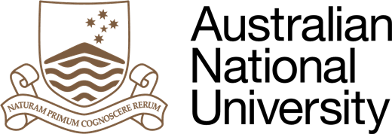 | 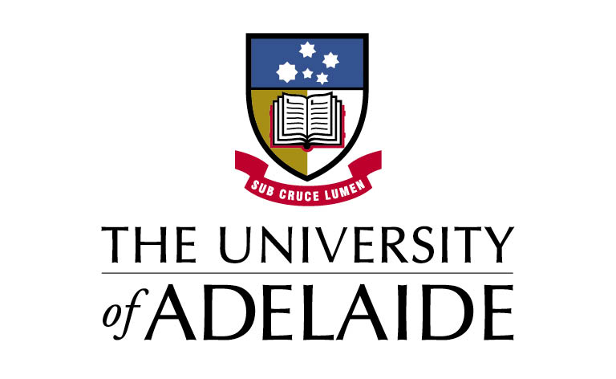
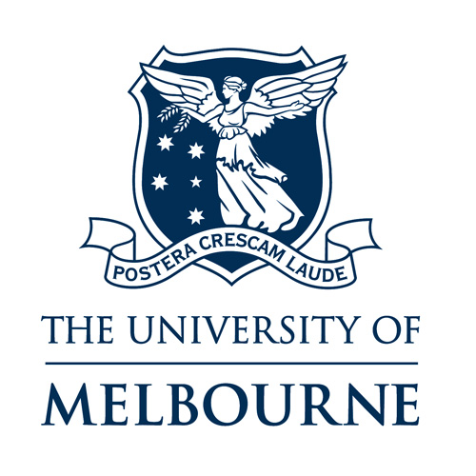 | 